◆ Platform User Guide — Teaching Teacher ◆
For: every teacher with a lesson in the unified lesson schedule
Your lesson in the external review starts from your cell in the schedule and ends with a documented score and one action you carry into your bridge card. This guide walks the whole way with you.
Before you start — four things that concern everyone
1. Open the link — https://ahseyam.github.io/unified-lesson/
2. Switch to English — the EN button, top right
3. Choose your role — one card per role
4. Enter your staff number — you are identified by it, not by your name

• Open the link: It runs on phone, laptop and tablet with nothing to install. Bookmark it — it is your single reference; do not rely on a copy someone sends you, or you will be working from yesterday's data.
• Switch to English: Press it once and the choice is remembered on your device. Arabic is the default for everyone, so nothing changes for your Arabic-speaking colleagues. You may enter your own text in English or Arabic — both are kept as typed.
• Choose your role: Each role sees only what concerns it: its own buttons, screens and reports. You will not see what is not yours, and you cannot press a button that destroys someone else's work.
• Enter your staff number: Names repeat and are spelled in different ways, so the same person appears twice in the reports. If your number is on the roster, your name and subject are filled in for you.
❖ Step by step — with pictures every screenshot is taken from the platform itself, not drawn or imagined
1 Sign in with your role
• Choose the “Teaching teacher” card, then enter your staff number and your name appears.
• You are asked for your subject — it is the subject you teach, and your row in the schedule is found by it.
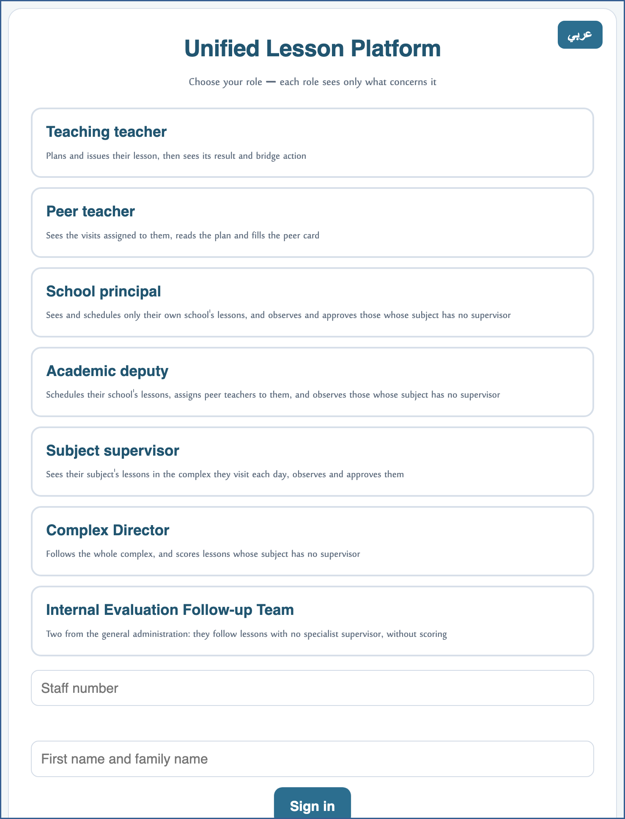
A live screenshot of the platform itself
2 Find your cell in the schedule
• The schedule is a matrix: rows are the week, the day and the visiting peer's subject; columns are the periods with their start times.
• Find your subject's row on the day your lesson runs, then go down to your period's column.
• Enter in the cell: your name, the strategy from the bank, the teaching approach, the class and the start time.
⛔ Do not write in a cell that is not your subject or your period — whatever is entered there becomes its owner's lesson.

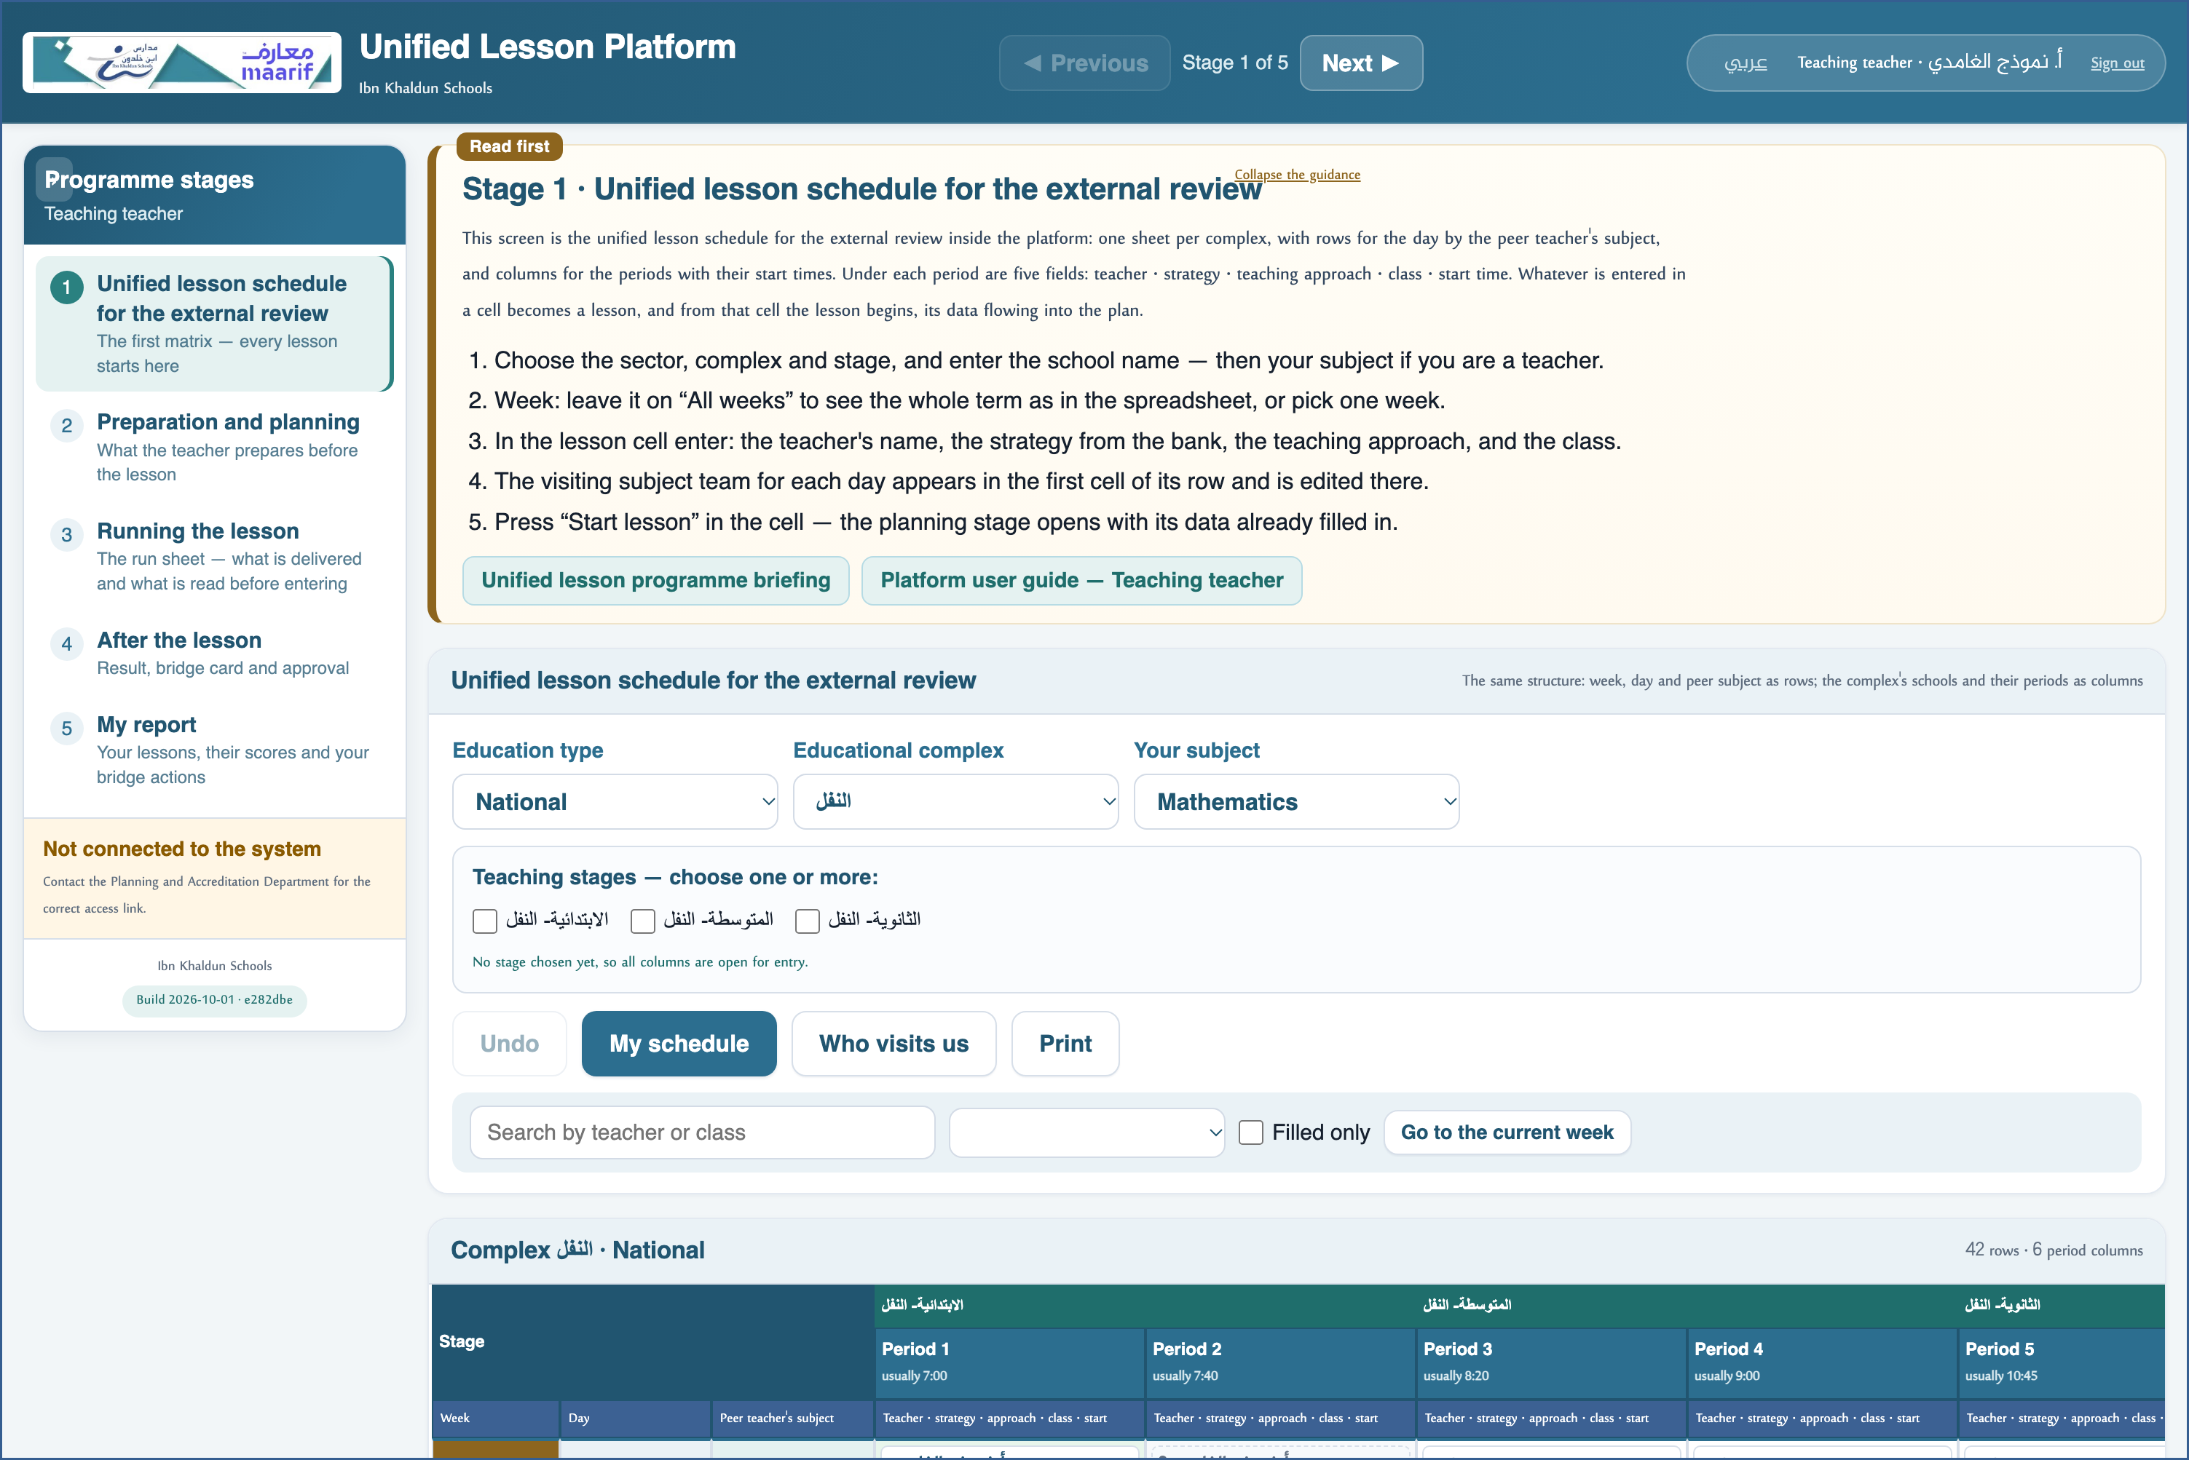
A live screenshot of the platform itself
3 Start the lesson from its cell
• Press “Start lesson” in the cell — the planning screen opens with its data already filled in.
• Complete the time map: warm-up, delivery, assessment and closure — their total is the lesson time.
• The priority-care time and the gifted time sit inside the delivery time; they are not added to it.
⛔ Do not issue the plan before it is complete: once issued, peers and observers read it.

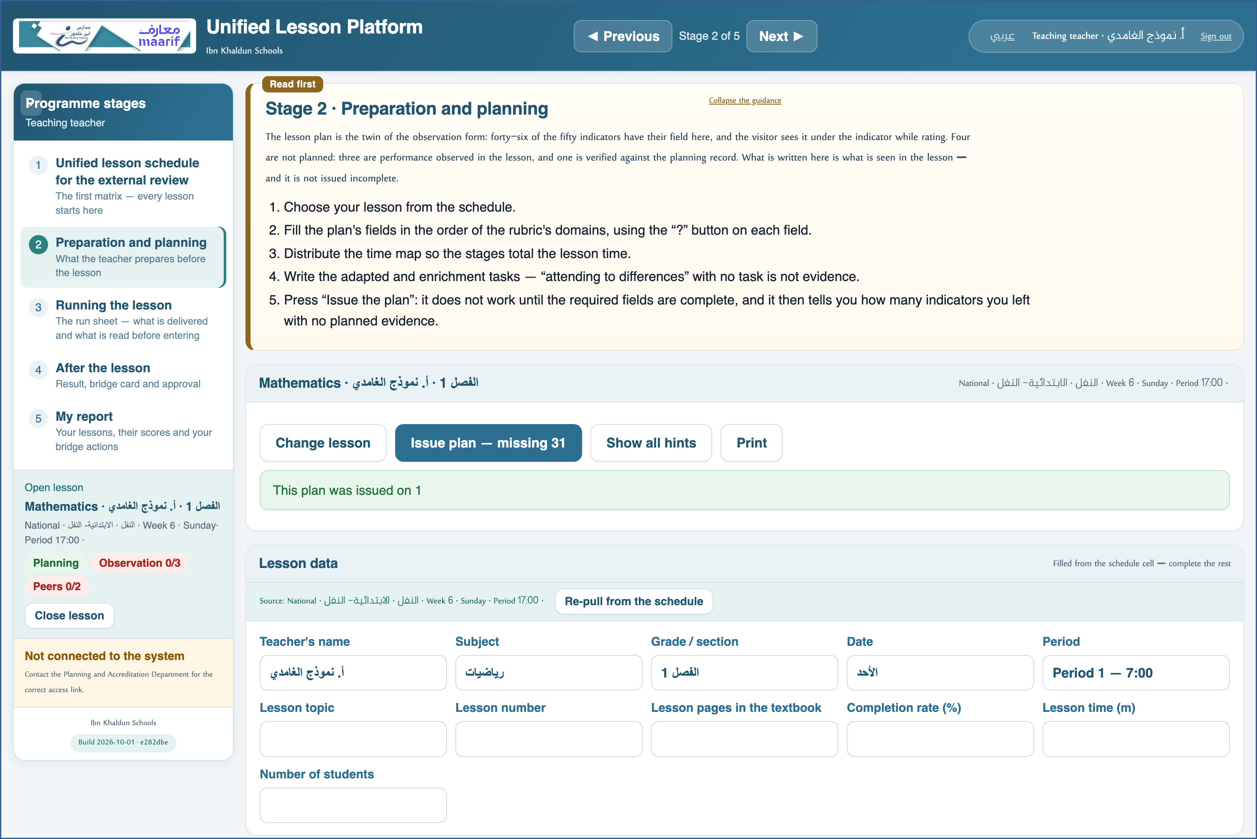
A live screenshot of the platform itself
4 Read the run sheet
• A short sheet to read before you walk in: what you will deliver and what will be recorded on you.
• Print it or open it on your phone — your whole plan on one page.
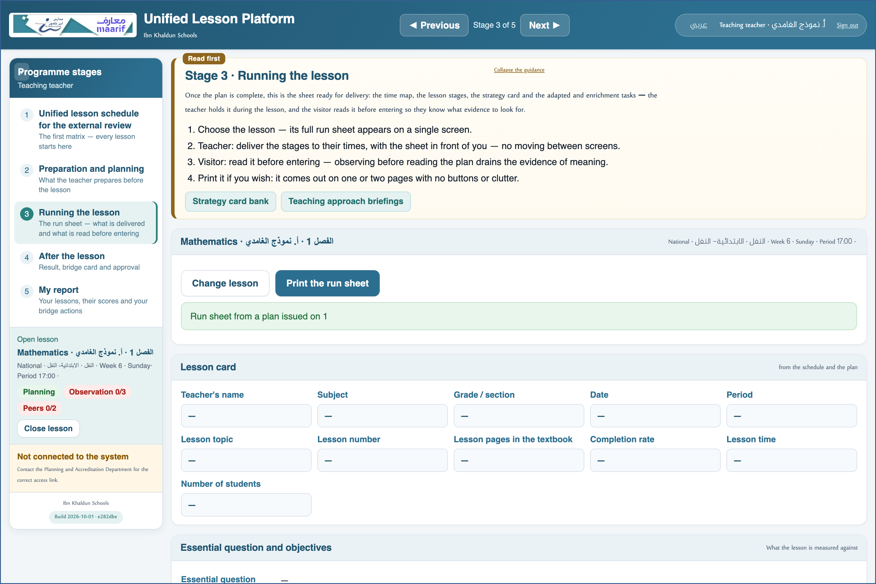
A live screenshot of the platform itself
5 Read your result and carry your action
• After the visit your score and its level appear, together with what each observer wrote about you.
• The “bridge action” is what you commit to in your next lesson — carry it into your card.
⛔ The score locks on approval: after that the schedule, the plan and the observations cannot be changed.

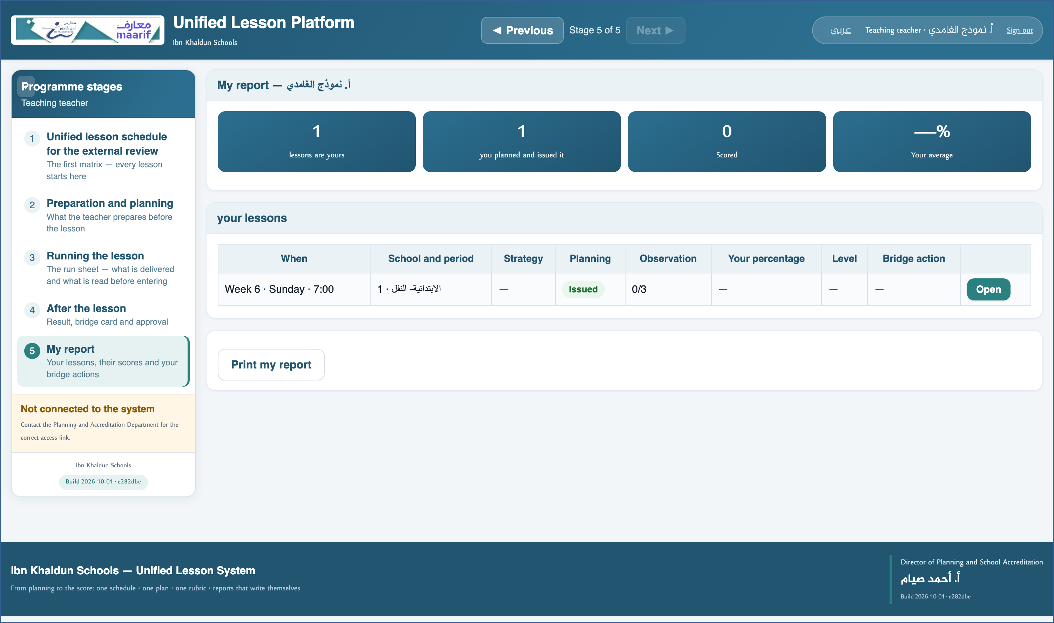
A live screenshot of the platform itself
❖ Where things usually go wrong before you ask — the most common cases
What happens | Why, and what to do
My lesson does not appear under “My schedule” | Your lesson is matched by your staff number. Check you signed in with your own number; if the cell was filled by someone else with your name spelled differently, ask them to use the “Register me here” button instead.
I cannot type in a particular cell | Either it belongs to a subject that is not yours, or its lesson has been approved and locked.

❖ Frequently asked
Q: Can anyone see my plan before I issue it?
A: No. Before you issue it, it is your draft alone.
Q: My colleagues work in Arabic — do we see the same data?
A: Yes. There is one shared store and one schedule; only the interface language differs. What you type stays exactly as you typed it.
Who to contact
If what concerns you does not appear, or something that is not yours does — contact the Planning and School Accreditation Department.
If the page does not open at all — check the link above and your connection.

https://ahseyam.github.io/unified-lesson/
Planning and School Accreditation Department · Ahmed Seyam

